SOC TEAM INTERNALS
SOC L1 ALERT TRIAGE WALKTHROUGH
Platform: TryHackMe.
Learning Objectives:
- Familiarise with the concept of SOC alert
- Explore alert fields, statuses, and classification
- Learn how to perform alert triage as an L1 analyst
- Practice with real alerts and SOC workflows
- Prepare for SOC Simulator
Task 1: INTRODUCTION
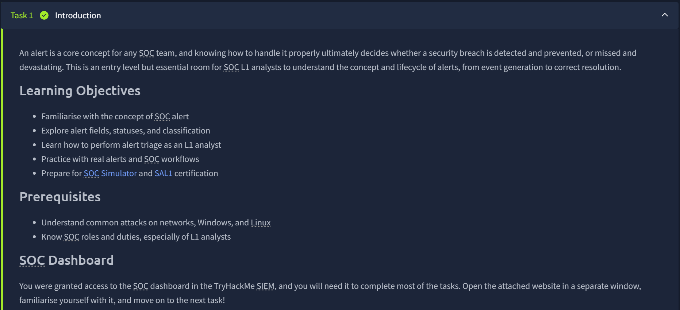
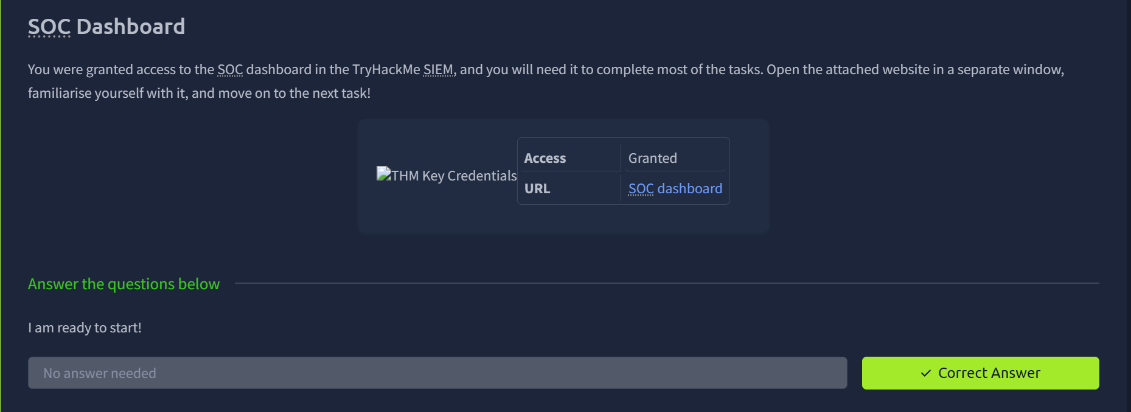

Task 2: EVENTS AND ALERTS
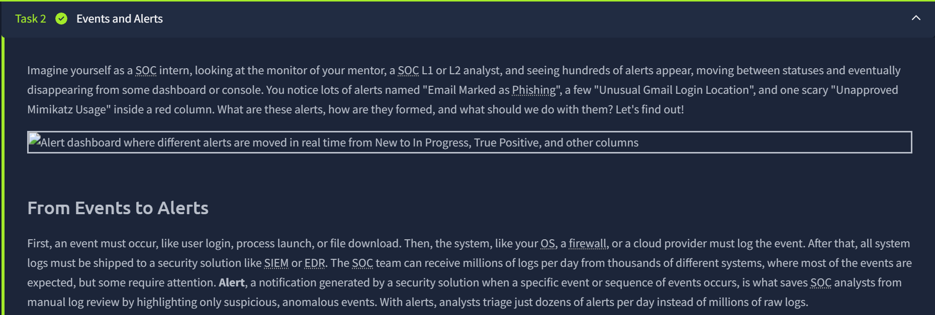
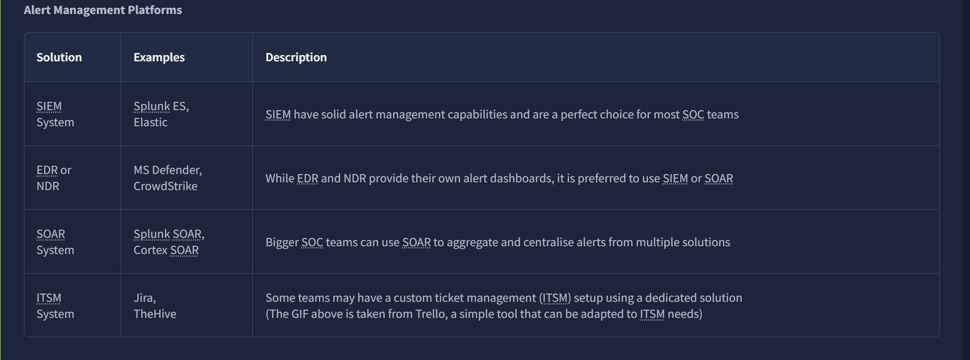
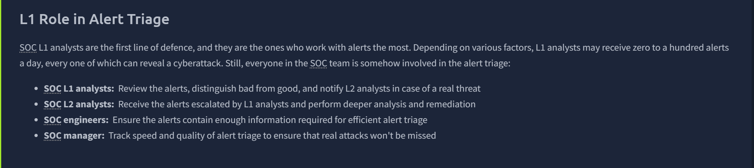
Task 2 Questions
Q: What is the number of alerts you see in the SOC dashboard (opens in new tab)?
Answer: 5

The SOC Dashboard
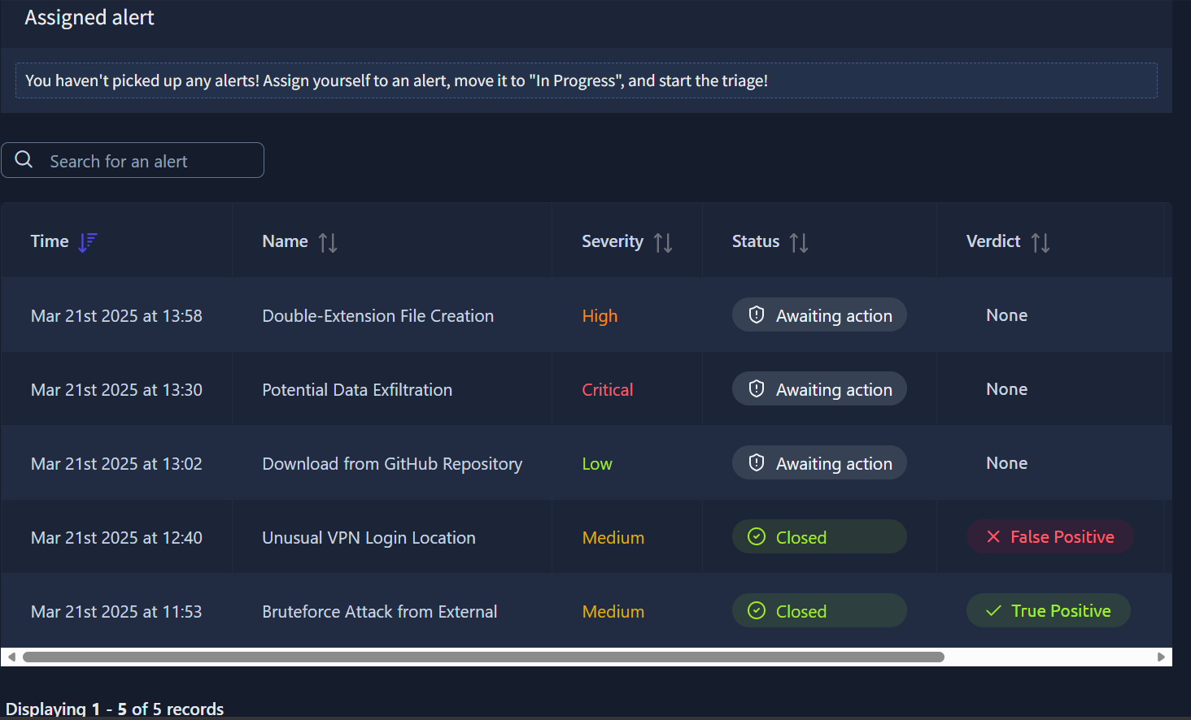
Q: What is the name of the most recent alert you see?
A: Double-Extension File Creation.
Created on Mar 21st 2025 at 13:58.

Task 3: ALERT PROPERTIES
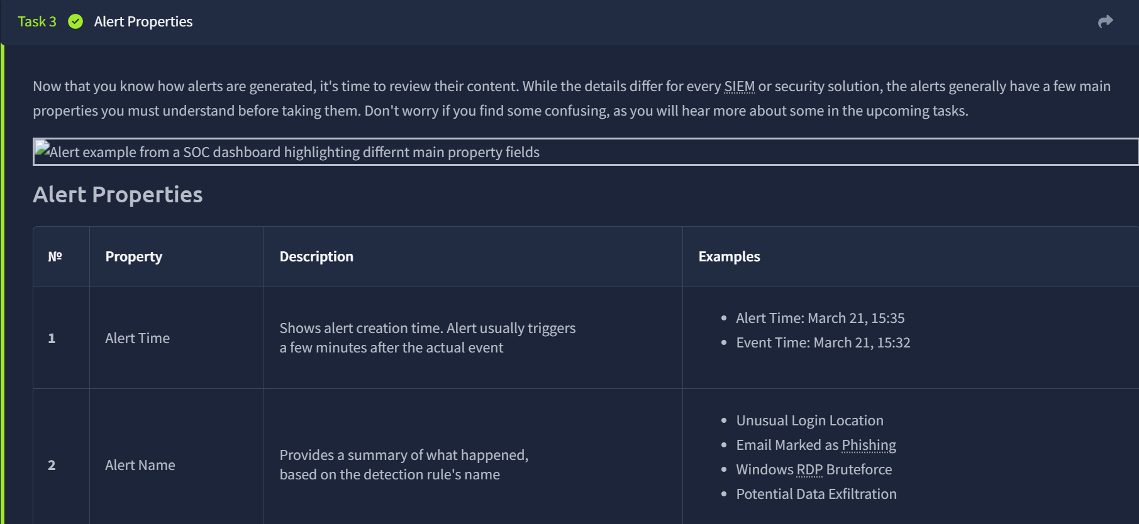
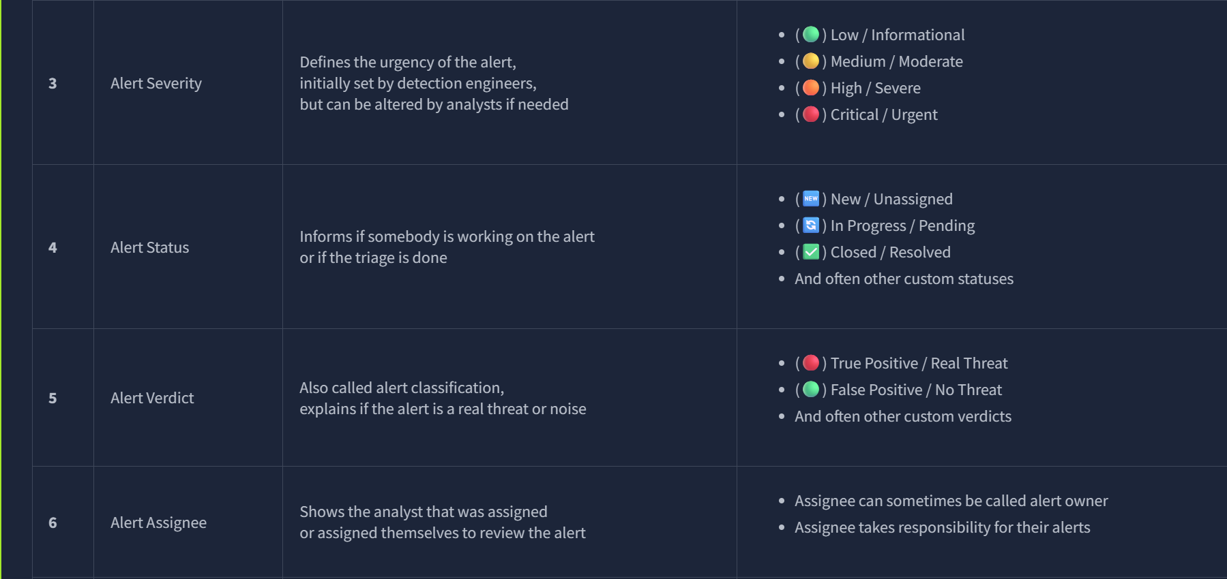
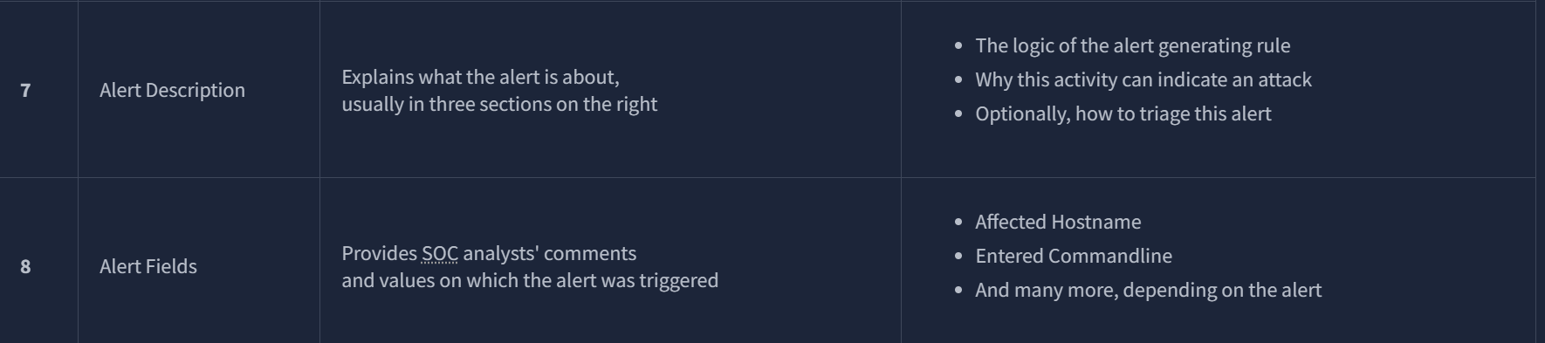
Task 3 Questions
Q: What was the verdict for the "Unusual VPN Login Location" alert?
A: False Positive
Q: What user was mentioned in the "Unusual VPN Login Location" alert?
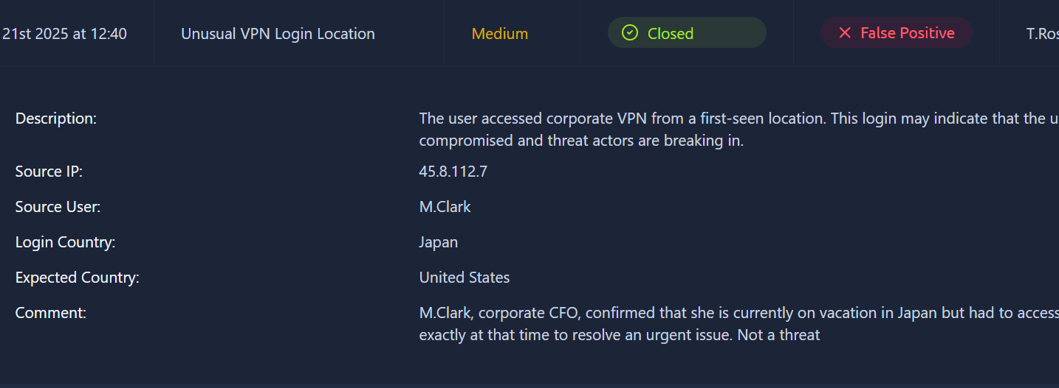
A: M.Clark

Task 4: ALERT PRIORITIZATION
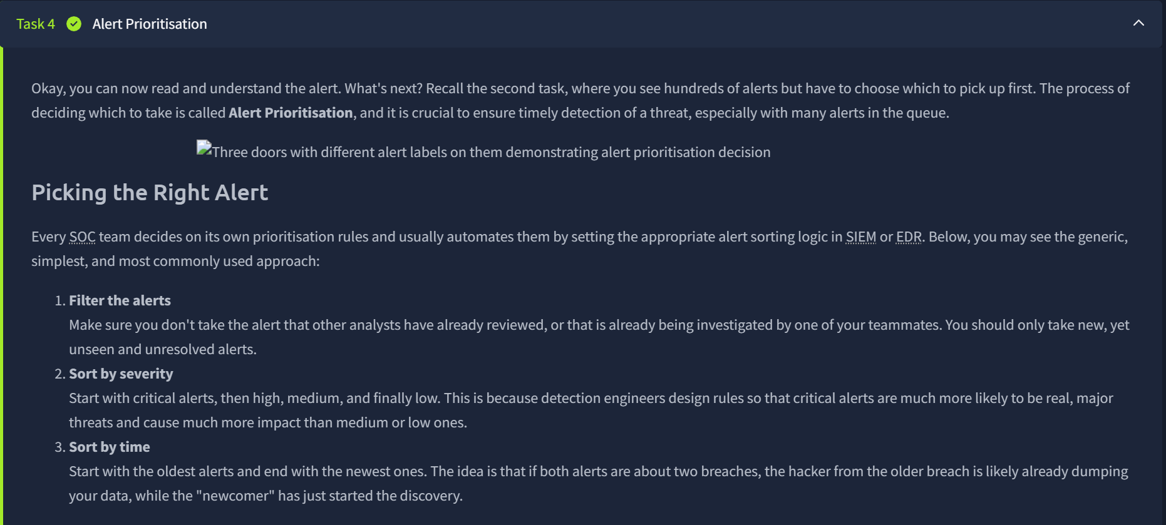
Task 4 Questions
Q: Should you first prioritise medium over low severity alerts? (Yea/Nay)
A: Yea
Q: Should you first take the newest alerts and then the older ones? (Yea/Nay)
A: Nay
Q: Assign yourself to the first-priority alert and change its status to In Progress.
The name of your selected alert will be the answer to the question.
I assigned myself Potential Data Exfiltration since it is a Critical, thus it being the first priority alert.
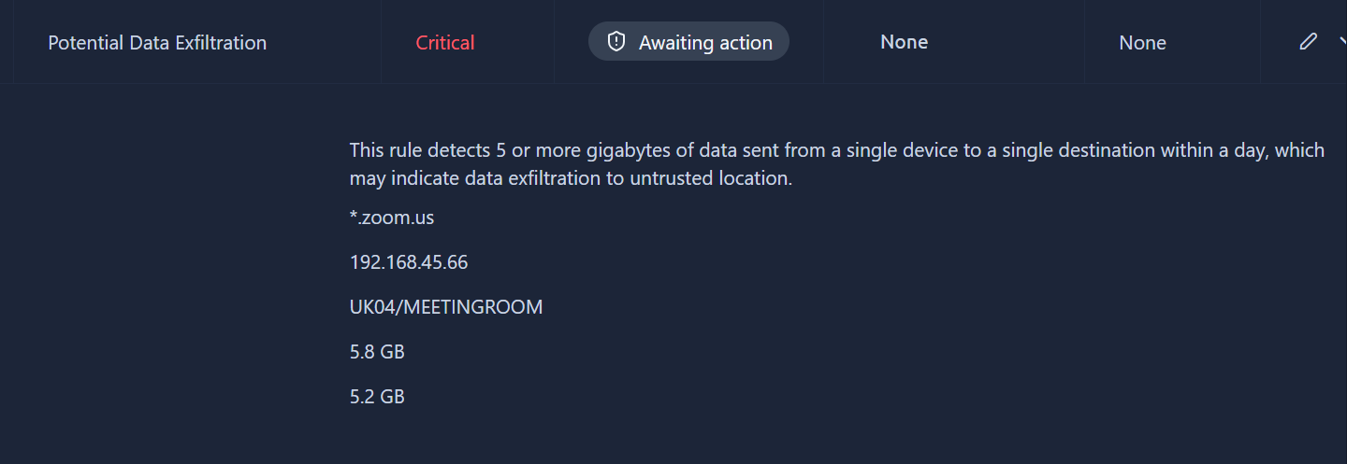
A: Potential Data Exfiltration.

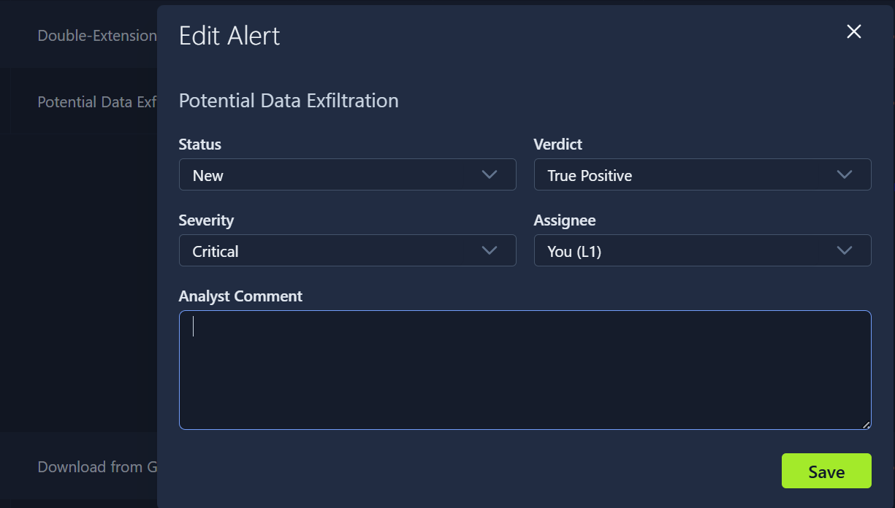
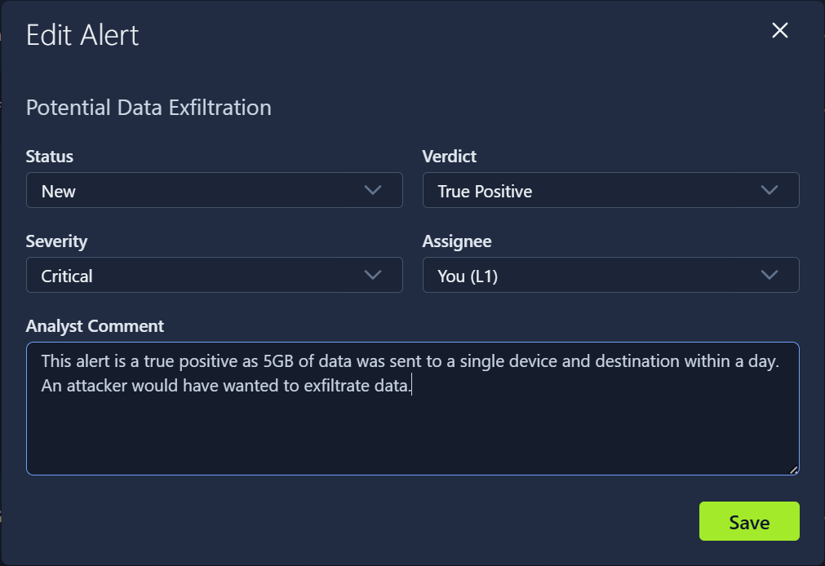
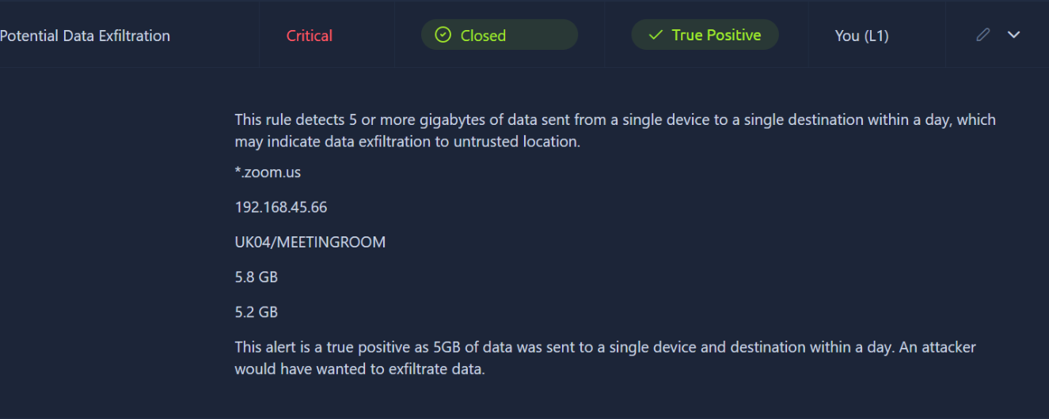
Task 4 Questions
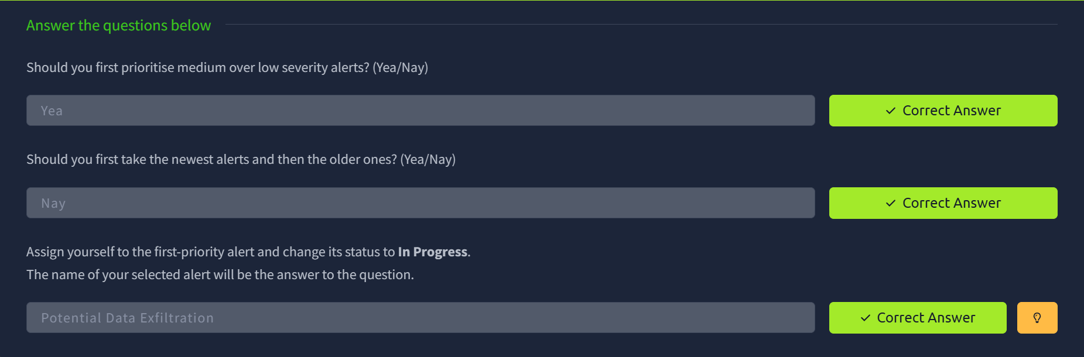

Task 5: Alert Triage
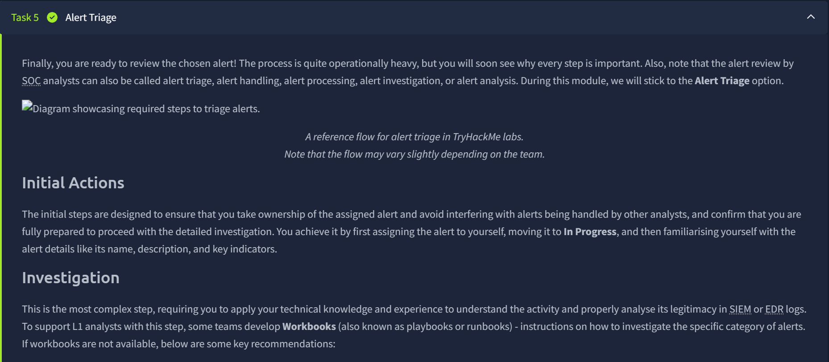
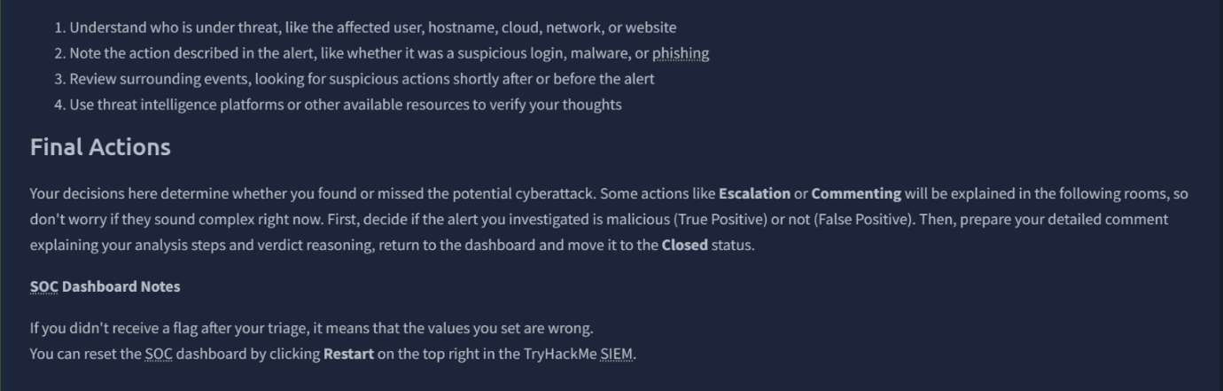
Task 5 Questions
Q: Which flag did you receive after you correctly triaged the first-priority alert?
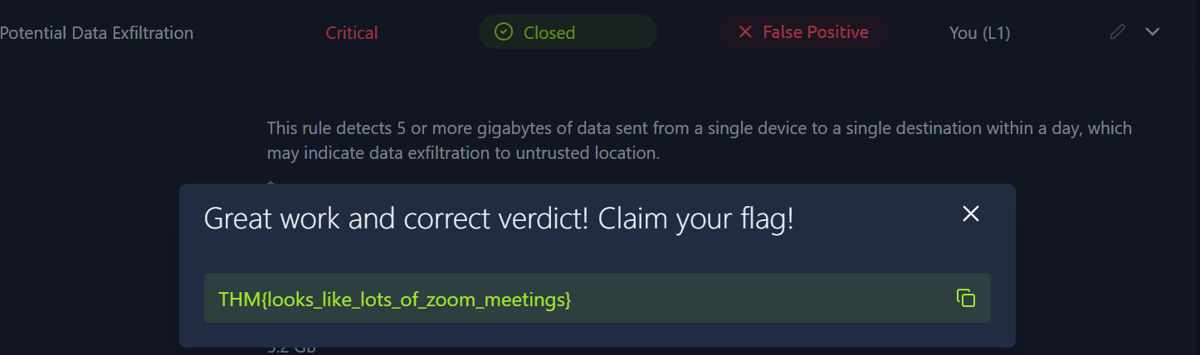
A: THM{looks_like_lots_of_zoom_meetings}

Q: Which flag did you receive after you correctly triaged the second-priority alert?
This is the Double File Extension Creation. It has a severity of High.
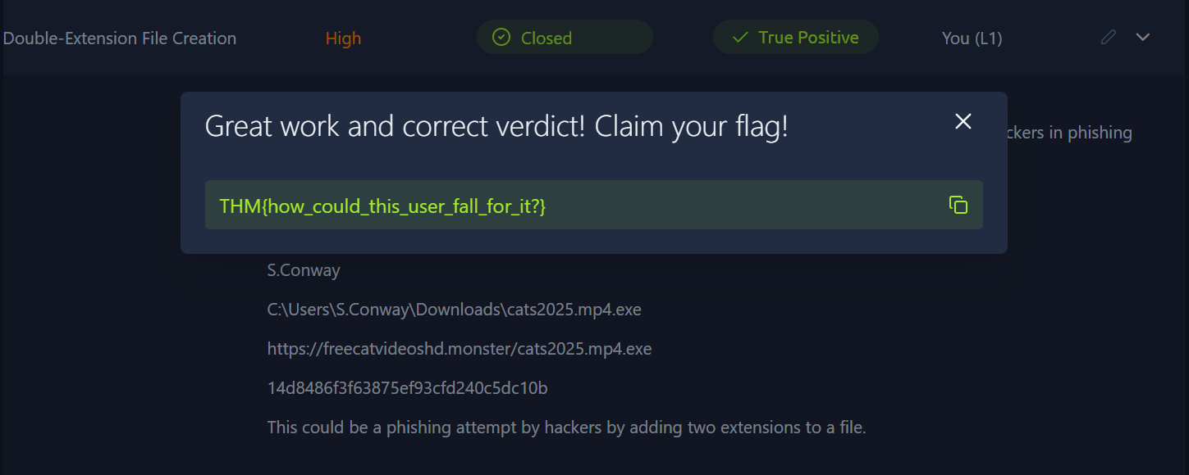
A: THM{how_could_this_user_fall_for_it?}

Q: Which flag did you receive after you correctly triaged the third-priority alert?
This is the Download from Github Repository with a low severity.
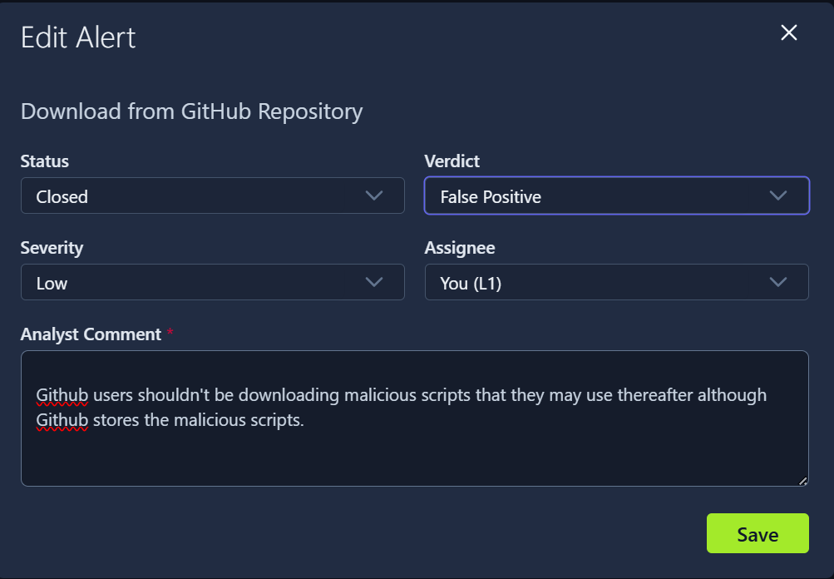
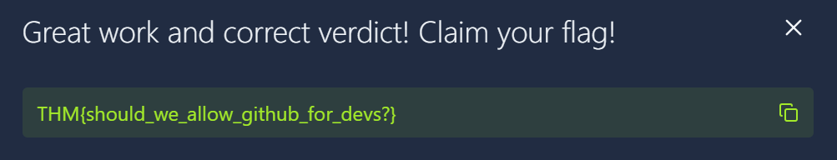
A: THM{should_we_allow_github_for_devs?}
Answers
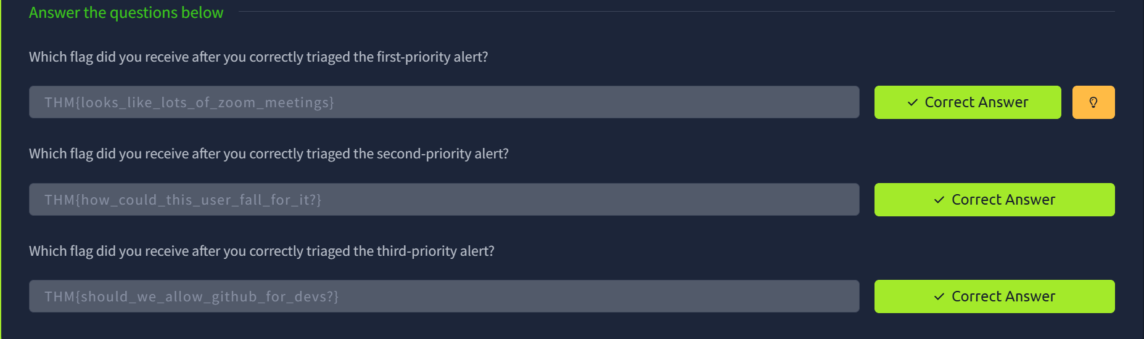
Task 6: CONCLUSION
